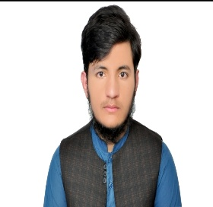
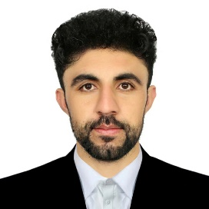

CURRICULUM VITEA

PERSONAL DETAILS:
Name: Mohammad Sharif “Sadiqi”
F/name: Mohammad Gousadin “Sadiqi”
Date of Birth: April/30/2005
Place of Birth: Ghazni, Afghanistan
Marital Status: Single
Province: Ghazni
Location: Kot-e-Sange Kabul, Afghanistan
Contact us@: WhatsApp, +93708345587 / Phone, +0745588064
Email: mohammadshirefsiddiqi@gmail.com

PROFESSIONAL EXPERIENCE:
- Fourth Semester

EDUCATIONS:
- Bachelor of Computer Science – Fourth semester student in Karwan University
- University, (Kabul, Afghanistan).

ACHIEVEMENT DIPLOMA & CERTIFICATES:

- Completed (Front End) In The Top Target (22 Jul 2026)
- Completed (CIT) In Javid Ibrahimi Course (Decembar 2025)

LANGUAGES:
- Pashto (Native)
- Dari (Fluent)
- English (Good)

SOFTWARE SKILLS:

• Front-End Development: HTML, CSS, JavaScript, Bootstrap, Tailwind CSS
• Responsive Design: Building mobile-friendly and desktop-optimized layouts
• UI/UX Awareness: Clean, modern, and user-friendly interface design
Framework Familiarity: Working with CSS frameworks and utility-first design systems

- Code Quality: Writing structured, maintainable, and standardized code

Available upon request

